CHEMICAL EQUILIBRIUM
(1) If aA + bB <--> cC + dD then 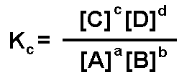
(2) KC = (1 / K’C ) in case of backward n forward and K’C = ( KC ) ^{n} where n is change in fraction of mole
(3) Kp = Kc (RT) ^{∆n} where ∆n is change in no of gas moles
(4) if Qc is less then Kc mean forward n vice versa and both are equal at equilibrium.
(5) log (K2/K1) = - (∆ H / 2.303R) (T₁- T₂ / T₁ T₂)
(6) log Kp = (∆S / 2.303R) – (∆H / 2.303RT)
(7) concentration of gas is equal to its pressure.
(8) According to Le Chatelier principle rxn goes forward when T iz in exothermic rxn,on iz the pressure rxn go to that direction that have lesser no of molecule and volume effect iz just reverse to pressure
(9) partial preesure of (A) = total pressure × mole fraction of (A)

